CERTIFICATE OF DELIVERY

DATE | 08/01/2026
EQUIPMENT | 4G LEVELLING TESTER

PHOTO | ITEM | CANT
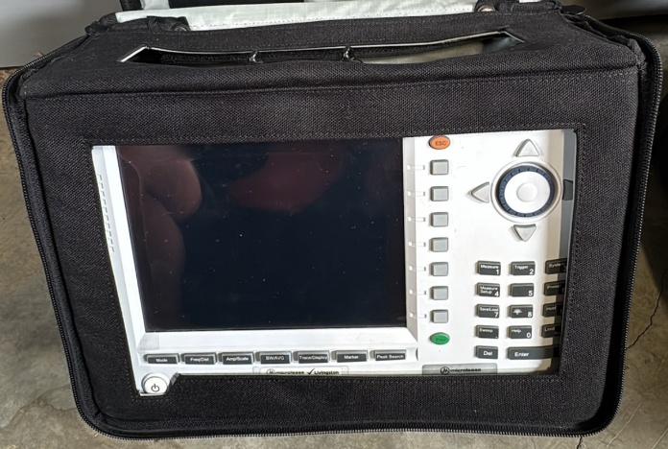 | JD745B  JDSU  EFA41123 | 1
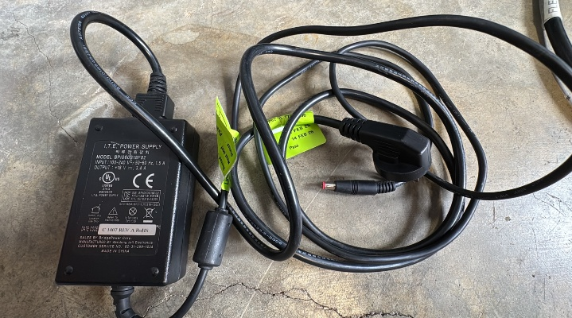 | Analyzer Power supply +18V / 3.4 A  BPI060S18F02 | 1
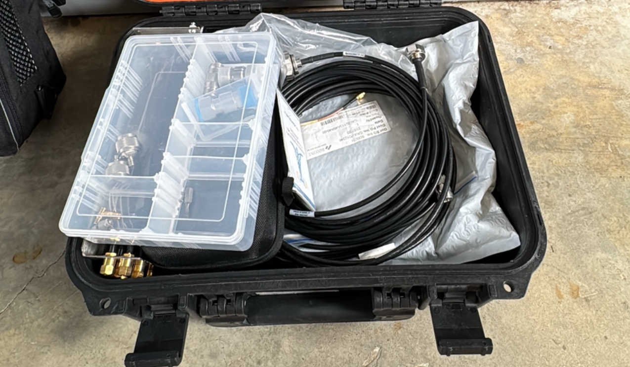 | Black bag | 1
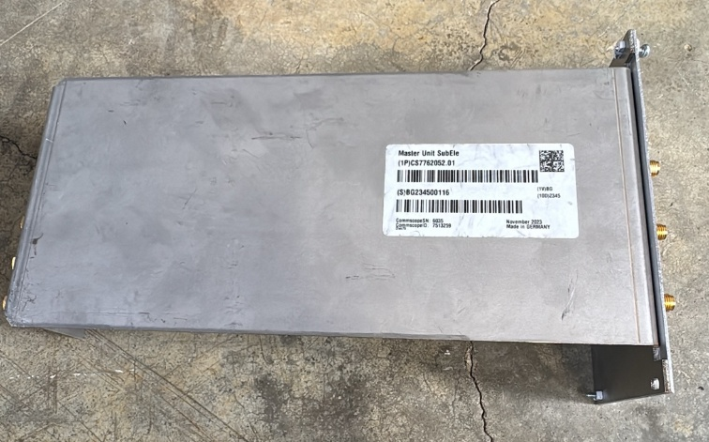 | Master Unit SubEle (Levelling adapter 6 ports)  Commscope  CS7762052.01  BG234500116 | 1
\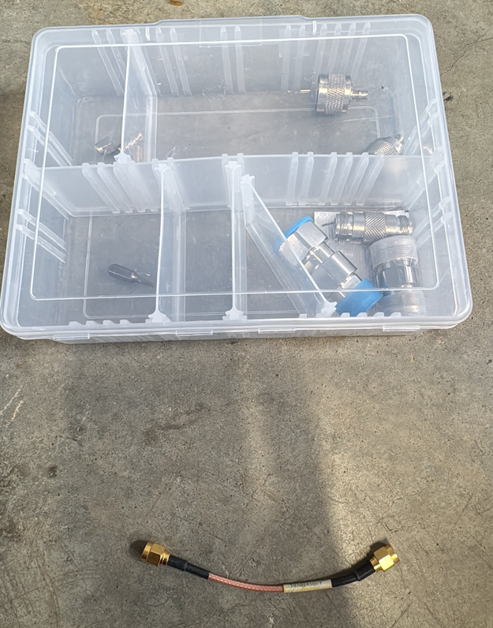 | Adaptors
 | 4.3-10-M to 4.3-10-F | 1
 | 4.3-10-F to 4.3-10-F | 1
 | SMA-M to SMA-M | 1
 | N-F to N-F | 0
 | N-F to DIN-F | 0
 | DIN-M to DIN-M | 0
 | N-M to DIN-F | 0
 | N-M (Connector) | 2
 | 4.3-10-M to N-F (Adaptor) | 1
 | Jumpers
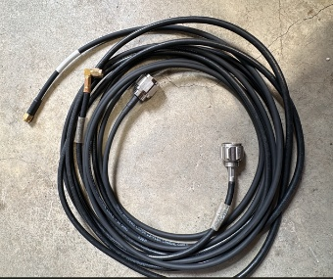  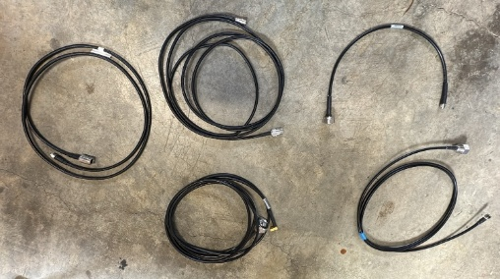  7  5  2  1  6  4  3  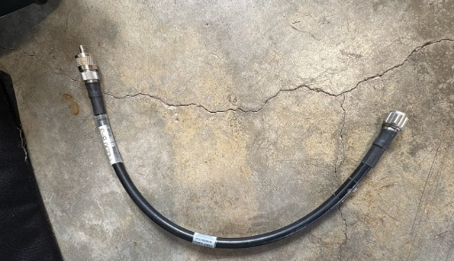  8 | (1) SMA-M to N-F 2Mts | 1
 | (2) SMA-M to 4.3-10-F 3Mts | 1
 | (3) SMA-M to DIN-M 2Mts | 1
 | (4) SMA-M to N-M 1Mts | 1
 | (5) SMA-M to DIN-M 0.5Mts | 1
 | (6) SMA-M RA to N-M 2Mts | 1
 | (7) SMA-M to N-M 2Mts | 1
 | (8) N-F to N-M 0.5Mts | 1

COMMENT:

